**Real-Time Facial Expression Recognition in Keras**

*Mini Project Report submitted in partial fulfilment of the requirements for the Degree of*

**BACHELOR OF TECHNOLOGY**

**In**

**COMPUTER SCIENCE AND ENGINEERING**

By

**Shubham Jain (11701185)**

**Abhishek Upadhyay (11714587)**

**Section: KM060**

Under the guidance of

**Mr. Sanjay Kumar Singh**



**School of Computer Science and Engineering**

Lovely Professional University

Phagwara, Punjab (India)

APRIL 2020

**1. Database link and description**

This dataset is taken from <https://www.kaggle.com/c/challenges-in-representation-learning-facial-expression-recognition-challenge/data>.It was first used in kaggle competition for representation learning and in ICML challenge. The actual data is divided into training and testing set and stored in the folder.

The data consists of 48x48 pixel grayscale images of faces. The faces have been automatically registered so that the face is more or less centered and occupies about the same amount of space in each image. The task is to categorize each face based on the emotion shown in the facial expression in to one of seven categories (0=Angry, 1=Disgust, 2=Fear, 3=Happy, 4=Sad, 5=Surprise, 6=Neutral).

Train.csv contains two columns, "emotion" and "pixels". The "emotion" column contains a numeric code ranging from 0 to 6, inclusive, for the emotion that is present in the image. The "pixels" column contains a string surrounded in quotes for each image. The contents of this string a space-separated pixel values in row major order. Test.csv contains only the "pixels" column and your task is to predict the emotion column.

The training set consists of 28,709 examples. The public test set used for the leader board consists of 3,589 examples. The final test set, which was used to determine the winner of the competition, consists of another 3,589 examples.

This dataset was prepared by Pierre-Luc Carrier and Aaron Courville, as part of an ongoing research project. They have graciously provided the workshop organizers with a preliminary version of their dataset to use for this contest.

**2. Code Implementation**

**# Libraries used**

1. **Numpy:** NumPy is a library for the Python programming language, adding support for large, multi-dimensional arrays and matrices, along with a large collection of high-level mathematical functions to operate on these arrays.
2. **Seaborn:** Seaborn is a Python data visualization library based on matplotlib. It provides a high-level interface for drawing attractive and informative statistical graphics.
3. **Matplotlib:** Matplotlib is a plotting library for the Python programming language and its numerical mathematics extension NumPy. It provides an object-oriented API for embedding plots into applications using general-purpose GUI toolkits like Tkinter, wxPython, Qt, or GTK+.
4. **Utils:** Python Utils is a module with some convenient utilities not included with the standard Python install.
5. **Os:** The OS module in python provides functions for interacting with the operating system. OS, comes under Python’s standard utility modules. This module provides a portable way of using operating system dependent functionality. The os and os.path modules include many functions to interact with the file system.
6. **TensorFlow:** TensorFlow is a free and open-source software library for dataflow and differentiable programming across a range of tasks. It is a symbolic math library, and is also used for machine learning applications such as neural networks.
7. **Keras:** Keras is an open-source neural-network library written in Python. It is capable of running on top of TensorFlow, Microsoft Cognitive Toolkit, R, Theano, or PlaidML. Designed to enable fast experimentation with deep neural networks, it focuses on being user-friendly, modular, and extensible.

**# Executable code explanation using comment lines**

1. **Used Libraries and Exploration of dataset**

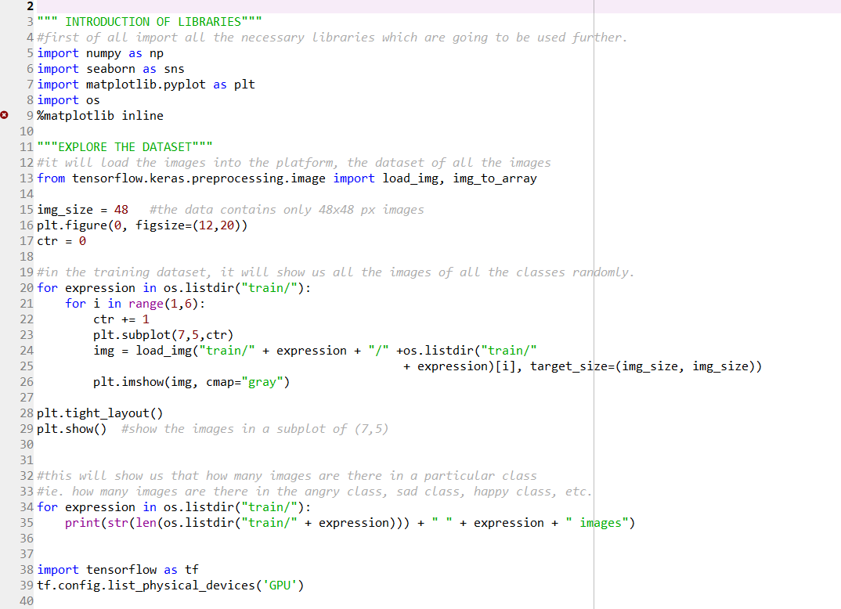

1. **Generate Training and Validation Batches**

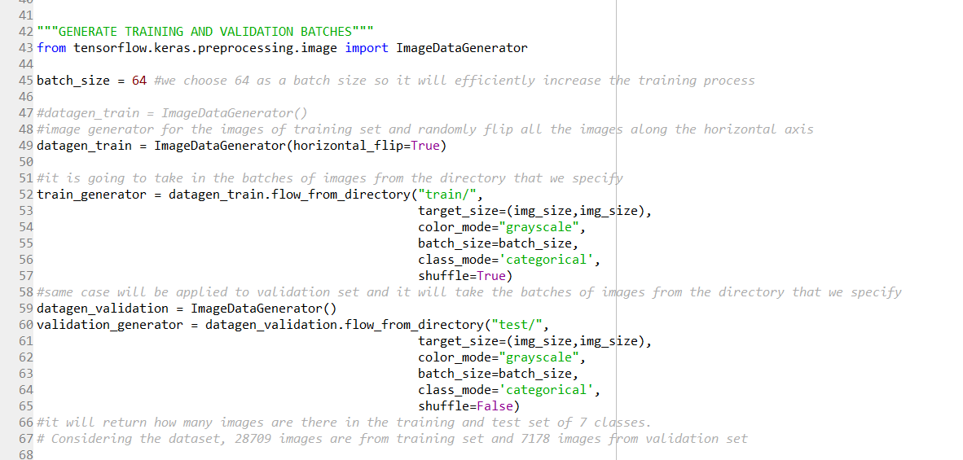

1. **Create a Convolutional Neural Network**

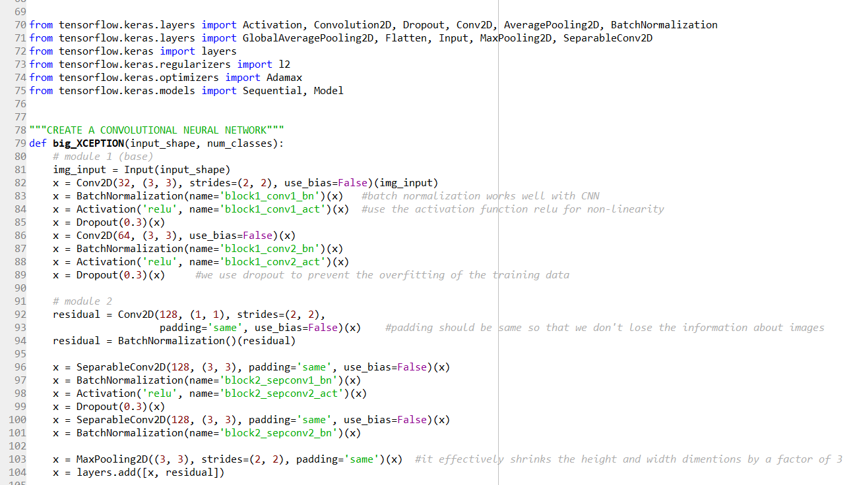

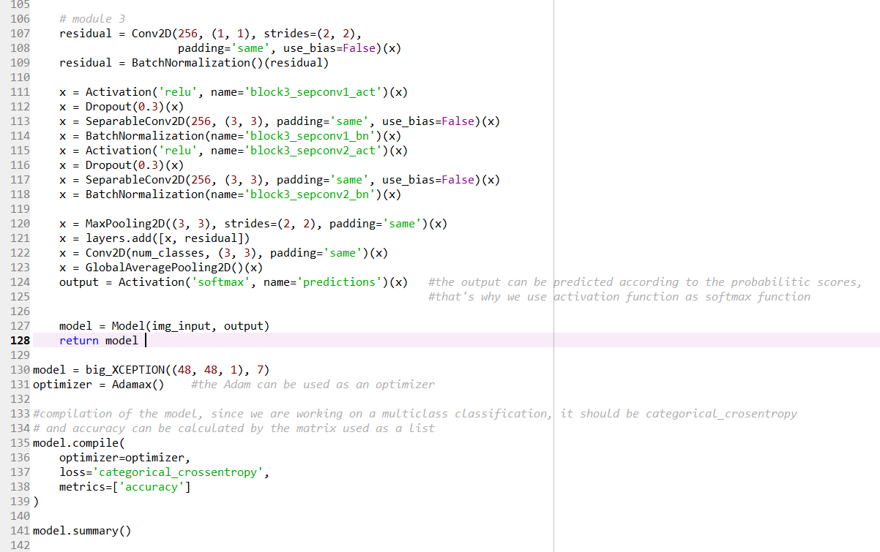

1. **Training and Evaluation of Model**

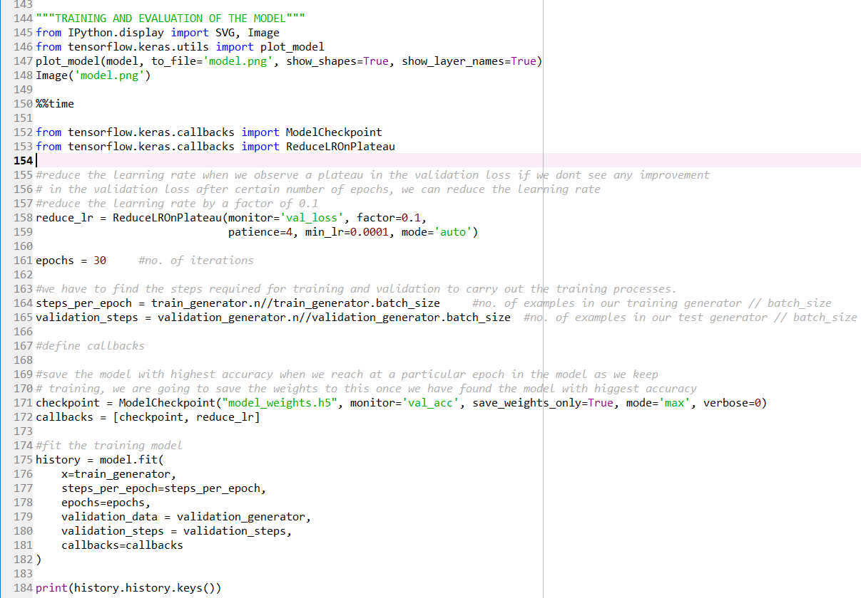

1. **Summarization of Accuracy**

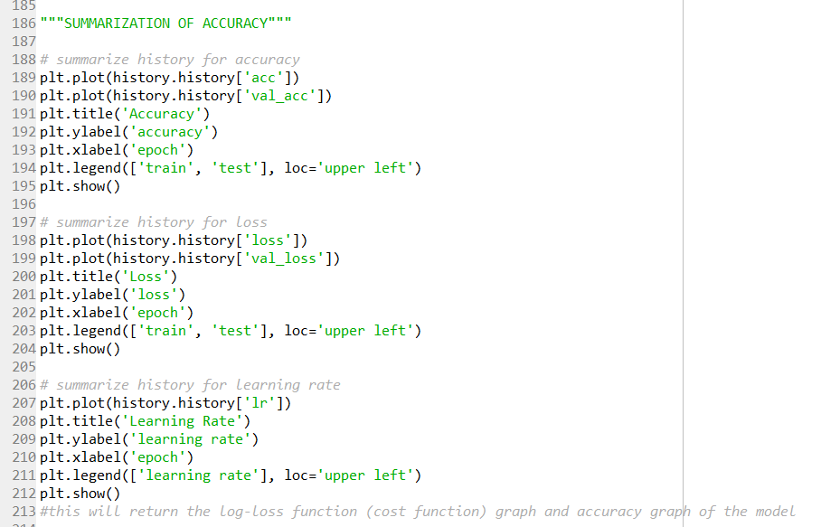

1. **Represent the Model as JSON String**

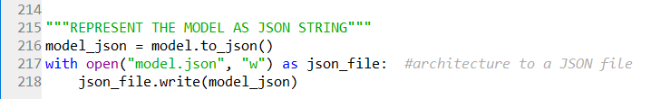

**3. Innovation**

**1. Videos:** Two videos are included to test the implementation of project in real time. One of the video contains the seven expressions on which model is tested. Second video is of presidential debate news and model is tested on this video to check accuracy.

**2. Images:** The training set consists of about 30,000 images of facial expressions of all types like anger, happy, fear, contempt, etc to train the convolutional model.

**3. GUI:** Flask is used to create a micro-web framework so that the model for facial expression recognition can be used for any video to show the facial expression at real time.

**4. Result Visualization and graphs**

**a. Plotting of sample images**

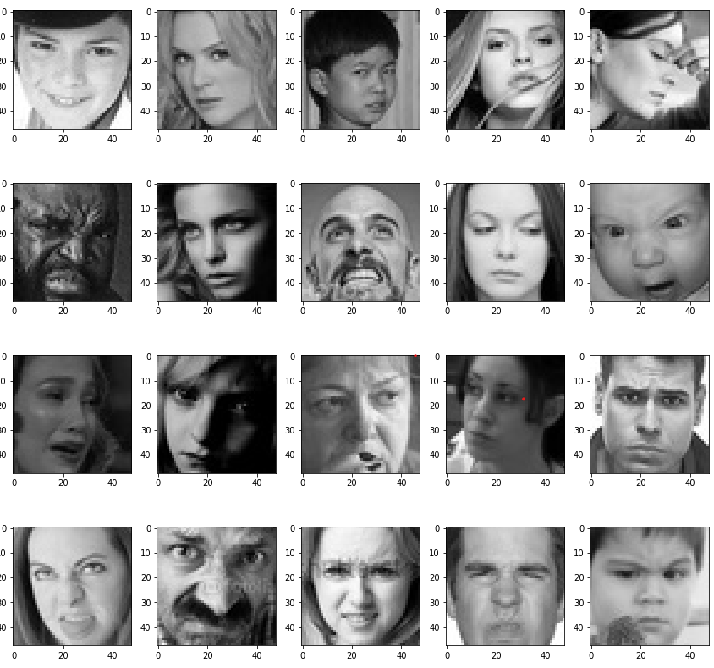

**b. Model Summary**

Model: "sequential" _________________________________________________________________

Layer (type) Output Shape Param # ================================================================= conv2d (Conv2D) (None, 48, 48, 64) 640 _________________________________________________________________ batch_normalization (BatchNo (None, 48, 48, 64) 256 _________________________________________________________________ activation (Activation) (None, 48, 48, 64) 0 _________________________________________________________________ max_pooling2d (MaxPooling2D) (None, 24, 24, 64) 0 _________________________________________________________________ dropout (Dropout) (None, 24, 24, 64) 0 _________________________________________________________________ conv2d_1 (Conv2D) (None, 24, 24, 128) 204928 _________________________________________________________________ batch_normalization_1 (Batch (None, 24, 24, 128) 512 _________________________________________________________________ activation_1 (Activation) (None, 24, 24, 128) 0 _________________________________________________________________ max_pooling2d_1 (MaxPooling2 (None, 12, 12, 128) 0 _________________________________________________________________ dropout_1 (Dropout) (None, 12, 12, 128) 0 _________________________________________________________________ conv2d_2 (Conv2D) (None, 12, 12, 512) 590336 _________________________________________________________________ batch_normalization_2 (Batch (None, 12, 12, 512) 2048 _________________________________________________________________ activation_2 (Activation) (None, 12, 12, 512) 0 _________________________________________________________________ max_pooling2d_2 (MaxPooling2 (None, 6, 6, 512) 0 _________________________________________________________________ dropout_2 (Dropout) (None, 6, 6, 512) 0 _________________________________________________________________ conv2d_3 (Conv2D) (None, 6, 6, 512) 2359808 _________________________________________________________________ batch_normalization_3 (Batch (None, 6, 6, 512) 2048 _________________________________________________________________ activation_3 (Activation) (None, 6, 6, 512) 0 _________________________________________________________________ max_pooling2d_3 (MaxPooling2 (None, 3, 3, 512) 0 _________________________________________________________________ dropout_3 (Dropout) (None, 3, 3, 512) 0 _________________________________________________________________ flatten (Flatten) (None, 4608) 0 _________________________________________________________________ dense (Dense) (None, 256) 1179904 _________________________________________________________________ batch_normalization_4 (Batch (None, 256) 1024 _________________________________________________________________ activation_4 (Activation) (None, 256) 0 _________________________________________________________________ dropout_4 (Dropout) (None, 256) 0 _________________________________________________________________ dense_1 (Dense) (None, 512) 131584 _________________________________________________________________ batch_normalization_5 (Batch (None, 512) 2048 _________________________________________________________________ activation_5 (Activation) (None, 512) 0 _________________________________________________________________ dropout_5 (Dropout) (None, 512) 0 _________________________________________________________________ dense_2 (Dense) (None, 7) 3591 =================================================================

Total params: 4,478,727 Trainable params: 4,474,759 Non-trainable params: 3,968 _________________________________________________________________

**c. Model Architecture**

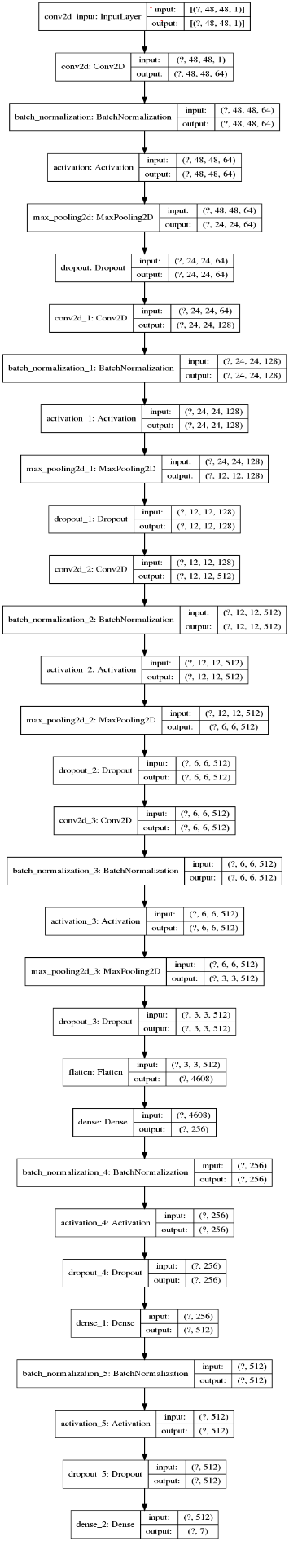

**d. Training and Evaluation**

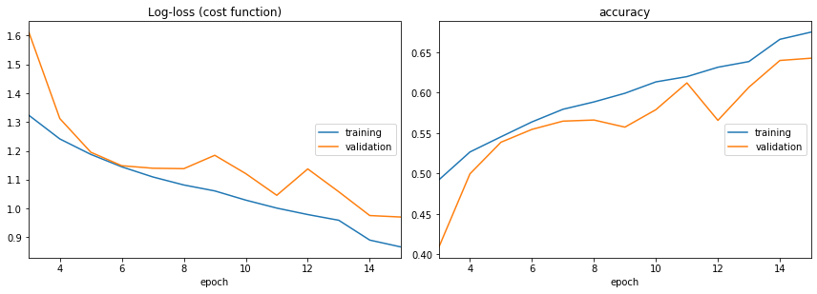

Log-loss (cost function):

training (min: 0.866, max: 1.786, cur: 0.866)

validation (min: 0.970, max: 1.705, cur: 0.970)

accuracy:

training (min: 0.313, max: 0.675, cur: 0.675)

validation (min: 0.381, max: 0.643, cur: 0.643)

Epoch 00015: saving model to model_weights.h5

448/448 [==============================] - 27s 60ms/step - loss: 0.8659 - accuracy: 0.6748 - val_loss: 0.9700 - val_accuracy: 0.6426

CPU times: user 6min 50s, sys: 57.4 s, total: 7min 47s

Wall time: 6min 46s

**5. Github link :**

Abhishek Upadhyay : <https://github.com/Abhileopan/Facial-Expression-Recognition-in-Keras>

Shubham Jain : <https://github.com/Shubham11Jain/Real-Time-Face-Expression-Recognition>